November | 2025
Sunday | Monday | Tuesday | Wednesday | Thursday | Friday | Saturday
 |  |  |  |  |  | 1
2 | 3 | 4 | 5 | 6 | 7 | 8
 |  |  | Adult Bible Group 6:30 PM |  | Spaghetti Dinner  Fundraiser 4p – 7p
9 | 10 | 11 | 12 | 13 | 14 | 15
Worship Committee Meeting after service Thanksgiving Baskets to Community Families |  |  | Pappy’s Lunch - noon  Adult Bible Group 6:30 PM | Young Adult & Youth Groups 6:30PM
16 | 17 | 18 | 19 | 20 | 21 | 22
 |  |  | Mission’s Committee  1:30PM  Adult Bible Group 6:30 PM | Young Adult Thanksgiving Pitch-In  6:30PM |  | Craft Fair Fundraiser @ Community Center 9a-12p
23 | 24 | 25 | 26 | 27 | 28 | 29
Thanksgiving Praise & Worship - Evening  30  5th  Sunday Offering Local Mission |  |  |  | 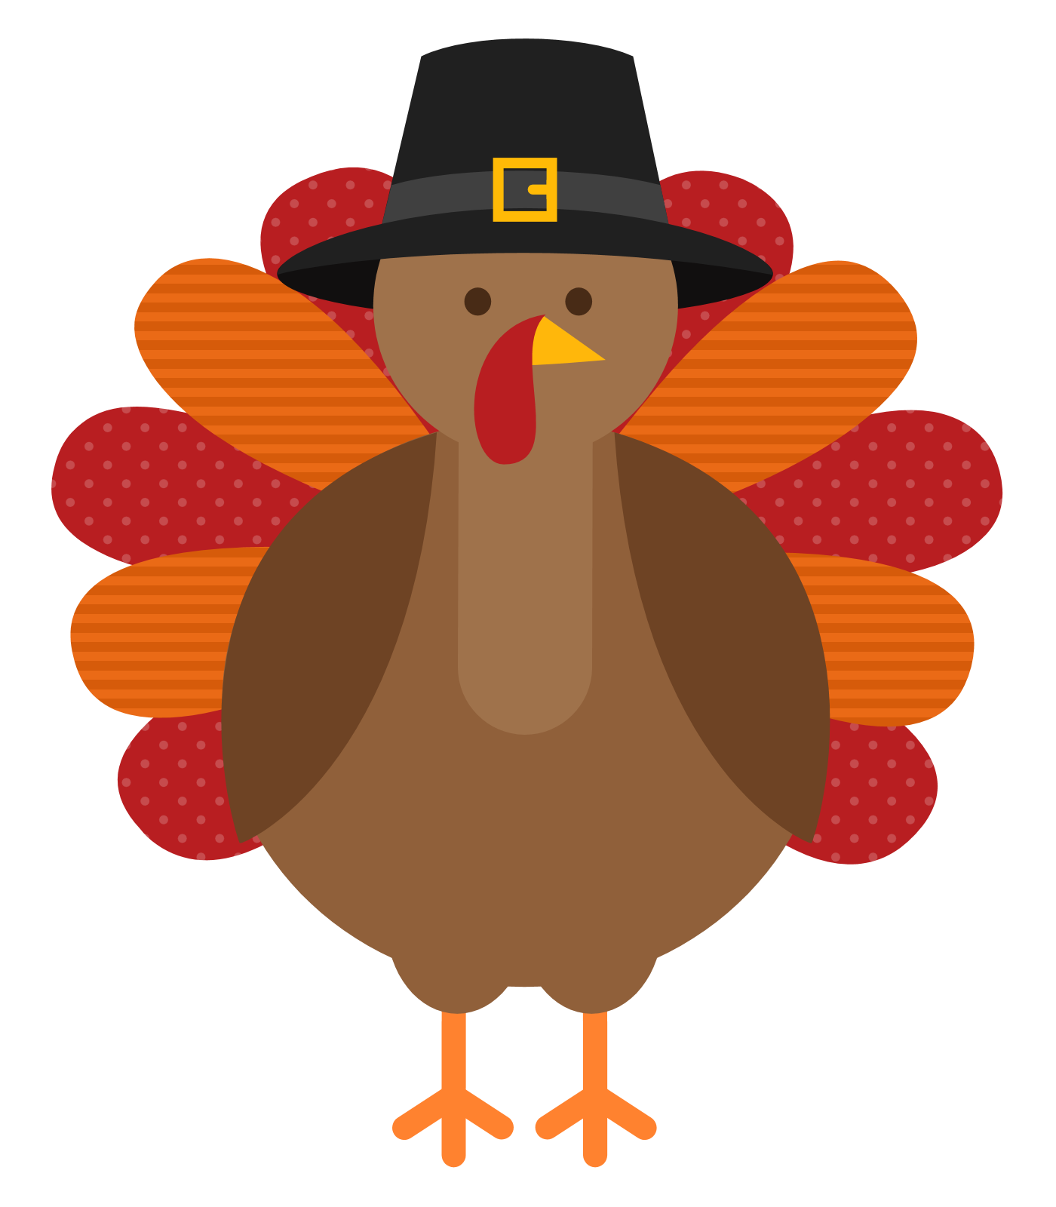  This Photo by Unknown Author is licensed under CC BY-NC |  | Hanging of the Greens – 10AM
Upcoming December Events:
FIRST SUNDAY OF EACH MONTH – FOYER FELLOWSHIP & DONUTS 9:45 am
12/07 – Board Meeting
Angel Tree Gifts – Foster Care Christmas – Christmas Eve Service

